Final -Project- Practical

Here is the first flag we get- screenshot is attached-

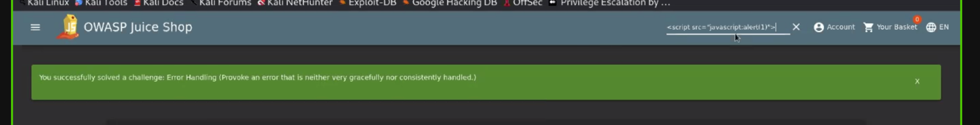

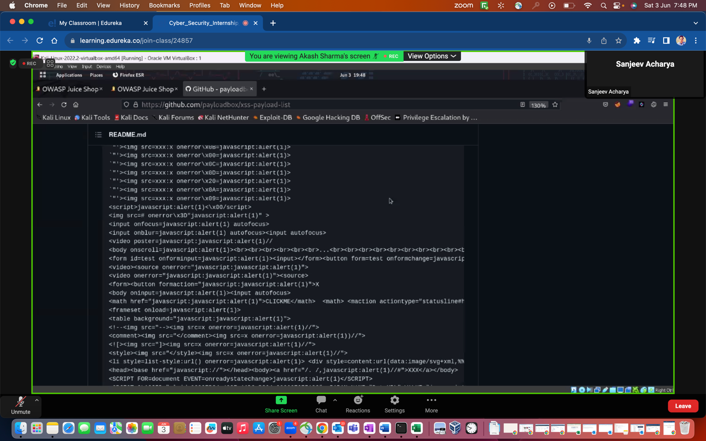

Documentation flag we caugh, & eroor flag

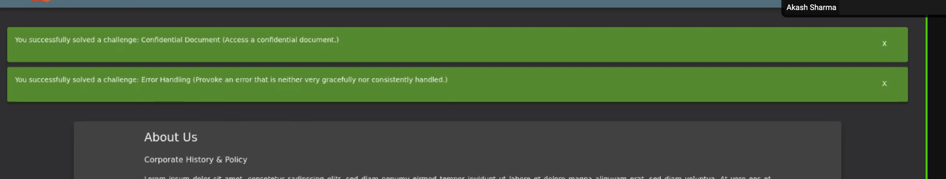

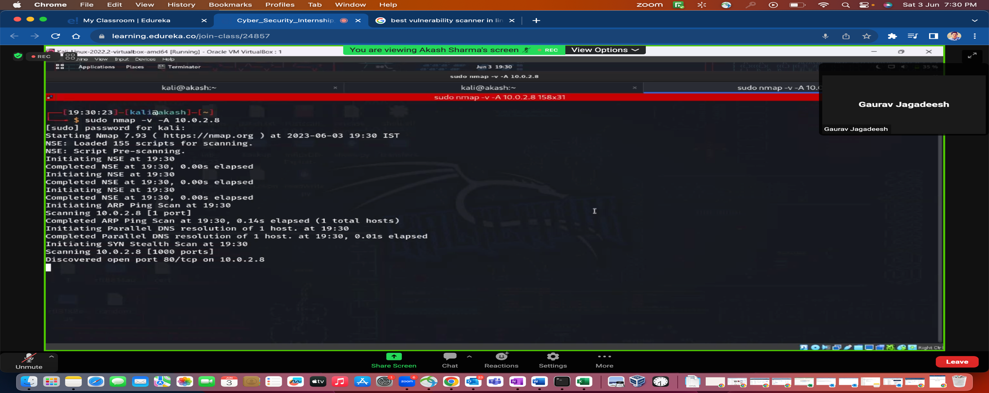

Here below- there are many Flag are caught- I caught one for Password one- screenshot is attached below

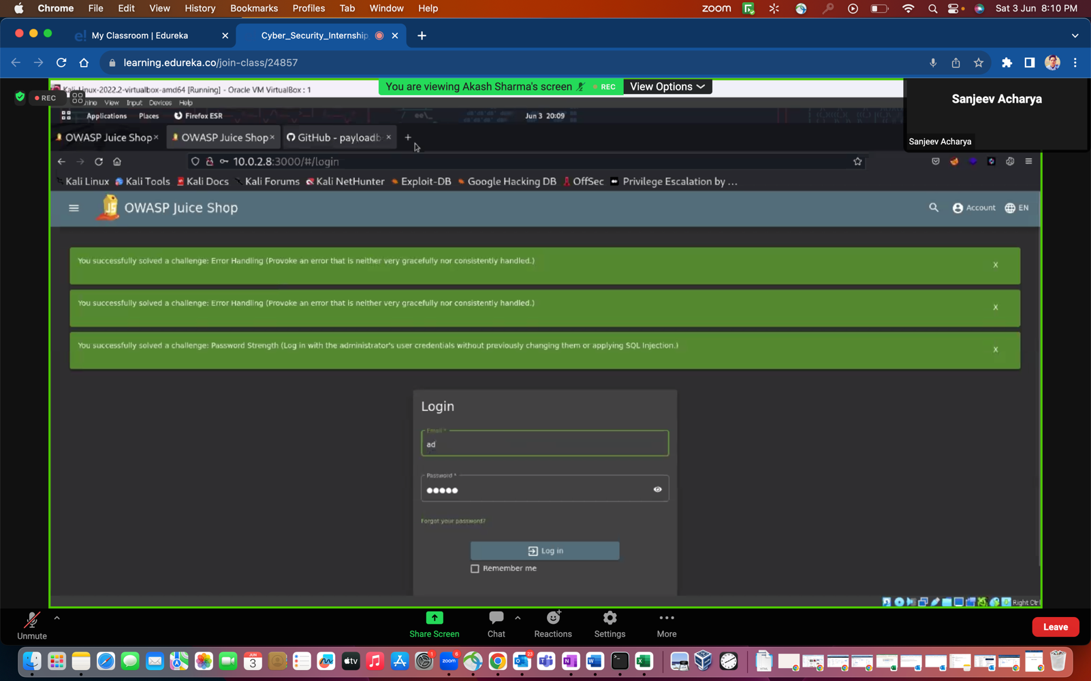

Another flag for the access one-

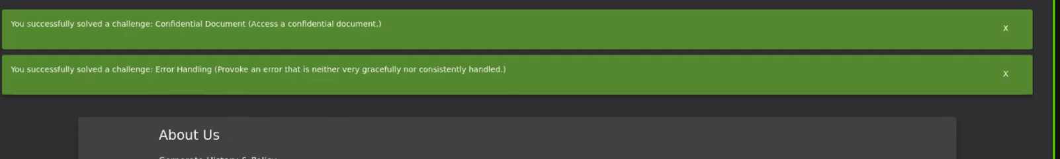

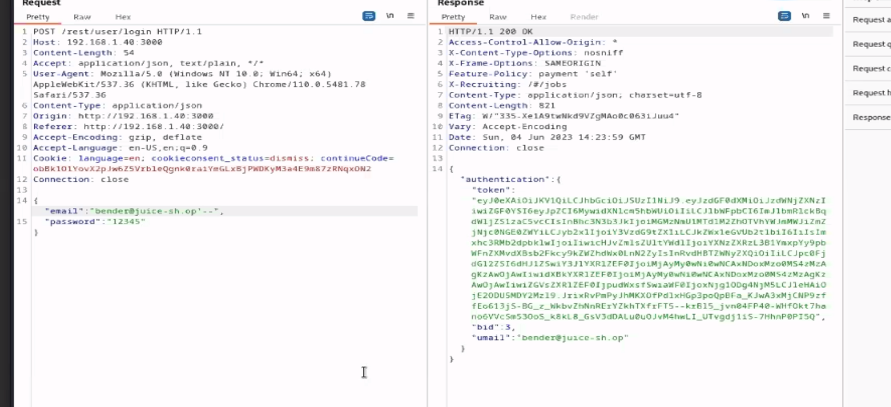

One flag for – Login flag

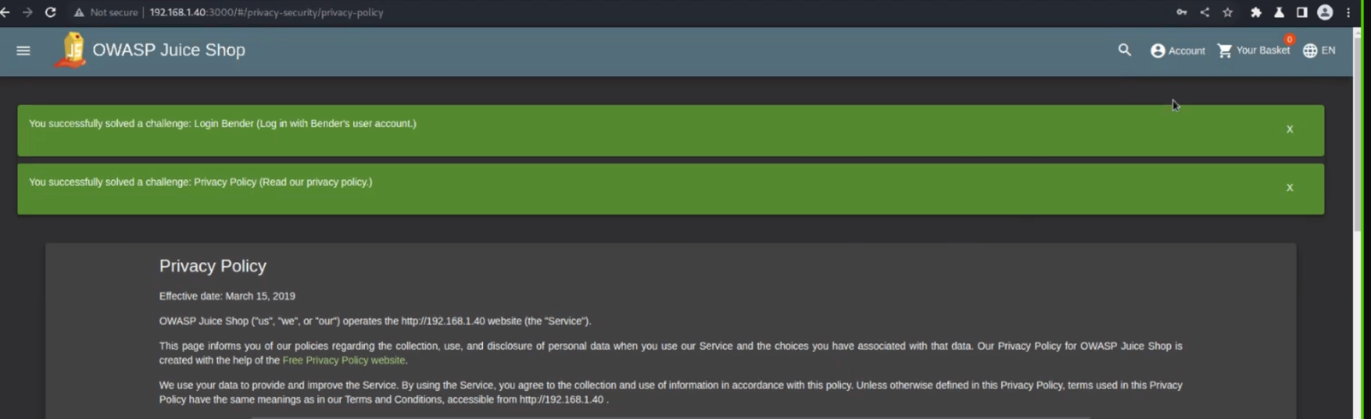

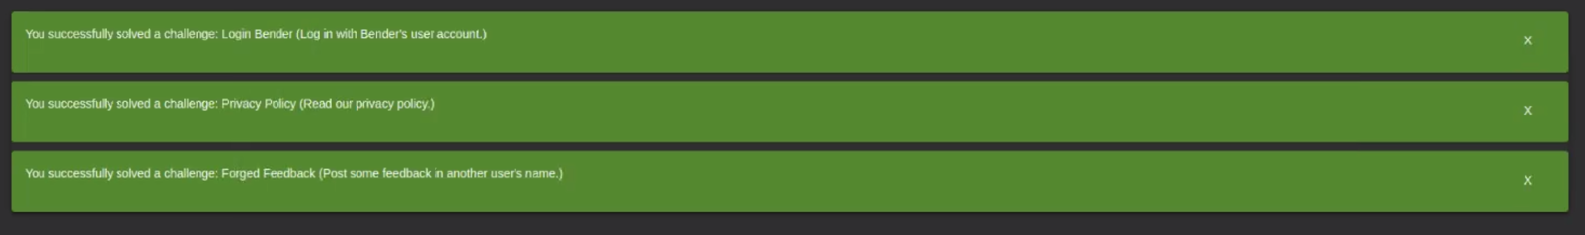

Login flag for admin acess –

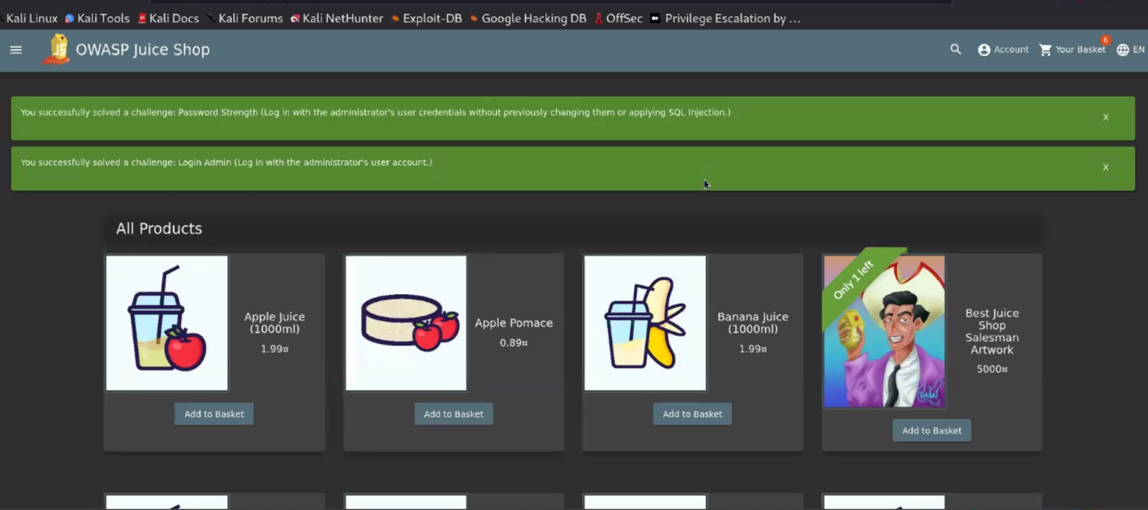

I tried it with the burb suite to crack the password and login in the admin account-

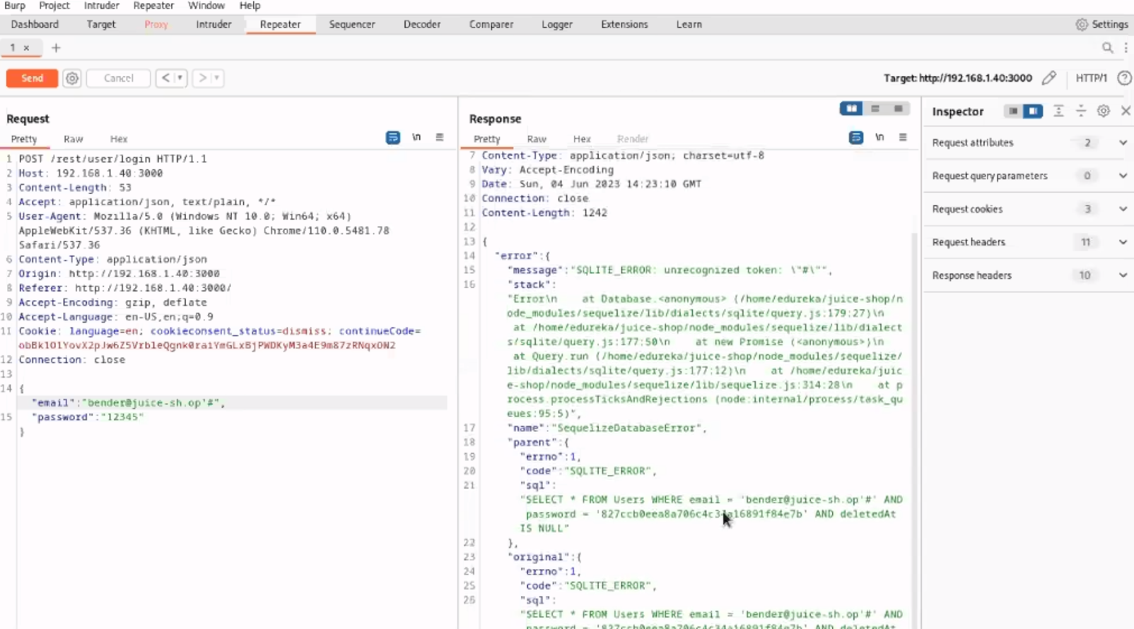

There are many more but I hope it’s fine to demonstrate my practical skills-